**Please follow the instructions to complete the hands-on. Each instruction expect a command for the Git Bash.**

**1. Verify if master is in clean state.**

**2. Create a branch “GitWork”. Add a file “hello.xml”.**

**3. Update the content of “hello.xml” and observe the status**

**4. Commit the changes to reflect in the branch**

**5. Switch to master.**

**6. Add a file “hello.xml” to the master and add some different content than previous.**

**7. Commit the changes to the master**

**8. Observe the log by executing “git log –oneline –graph –decorate –all”**

**9. Check the differences with Git diff tool**

**10. For better visualization, use P4Merge tool to list out all the differences between master and branch**

**11. Merge the bran to the master 1**

**2. Observe the git mark up.**

**13. Use 3-way merge tool to resolve the conflict**

**14. Commit the changes to the master, once done with conflict**

**15. Observe the git status and add backup file to the .gitignore file.**

**16. Commit the changes to the .gitignore**

**17. List out all the available branches**

**18. Delete the branch, which merge to master.**

**19. Observe the log by executing “git log –oneline –graph –decorate”**

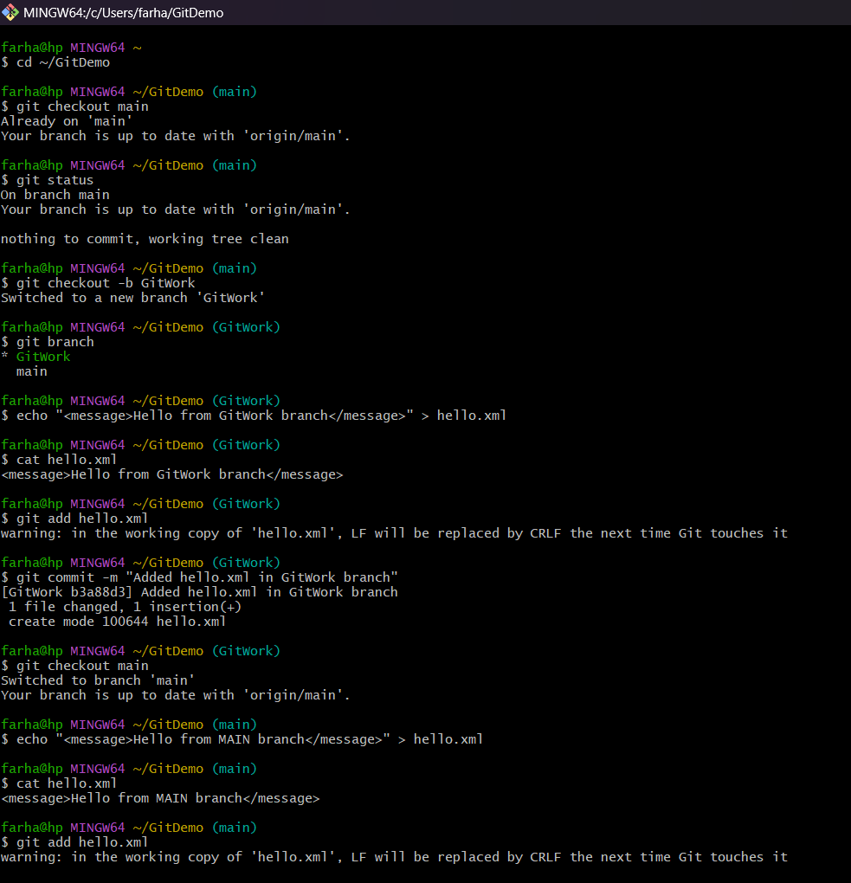**CODE:**

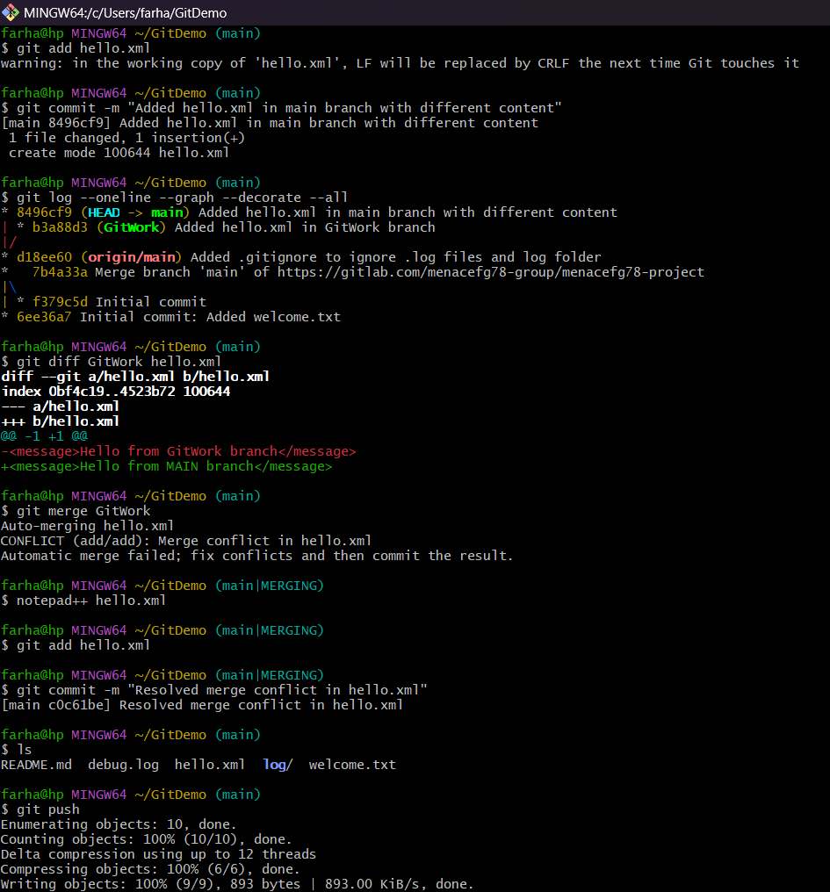

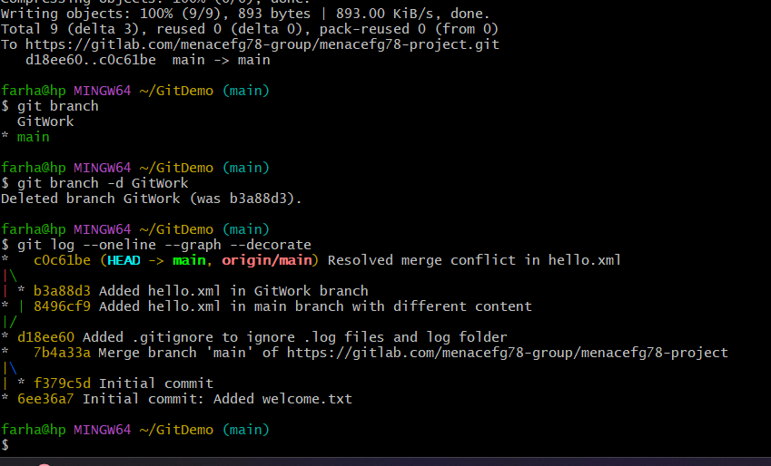

**Code as Text:**

farha@hp MINGW64 ~

$ cd ~/GitDemo

farha@hp MINGW64 ~/GitDemo (main)

$ git checkout main

Already on 'main'

Your branch is up to date with 'origin/main'.

farha@hp MINGW64 ~/GitDemo (main)

$ git status

On branch main

Your branch is up to date with 'origin/main'.

nothing to commit, working tree clean

farha@hp MINGW64 ~/GitDemo (main)

$ git checkout -b GitWork

Switched to a new branch 'GitWork'

farha@hp MINGW64 ~/GitDemo (GitWork)

$ git branch

* GitWork

main

farha@hp MINGW64 ~/GitDemo (GitWork)

$ echo "<message>Hello from GitWork branch</message>" > hello.xml

farha@hp MINGW64 ~/GitDemo (GitWork)

$ cat hello.xml

<message>Hello from GitWork branch</message>

farha@hp MINGW64 ~/GitDemo (GitWork)

$ git add hello.xml

warning: in the working copy of 'hello.xml', LF will be replaced by CRLF the next time Git touches it

farha@hp MINGW64 ~/GitDemo (GitWork)

$ git commit -m "Added hello.xml in GitWork branch"

[GitWork b3a88d3] Added hello.xml in GitWork branch

1 file changed, 1 insertion(+)

create mode 100644 hello.xml

farha@hp MINGW64 ~/GitDemo (GitWork)

$ git checkout main

Switched to branch 'main'

Your branch is up to date with 'origin/main'.

farha@hp MINGW64 ~/GitDemo (main)

$ echo "<message>Hello from MAIN branch</message>" > hello.xml

farha@hp MINGW64 ~/GitDemo (main)

$ cat hello.xml

<message>Hello from MAIN branch</message>

farha@hp MINGW64 ~/GitDemo (main)

$ git add hello.xml

warning: in the working copy of 'hello.xml', LF will be replaced by CRLF the next time Git touches it

farha@hp MINGW64 ~/GitDemo (main)

$ git commit -m "Added hello.xml in main branch with different content"

[main 8496cf9] Added hello.xml in main branch with different content

1 file changed, 1 insertion(+)

create mode 100644 hello.xml

farha@hp MINGW64 ~/GitDemo (main)

$ git log --oneline --graph --decorate --all

* 8496cf9 (HEAD -> main) Added hello.xml in main branch with different content

| * b3a88d3 (GitWork) Added hello.xml in GitWork branch

|/

* d18ee60 (origin/main) Added .gitignore to ignore .log files and log folder

* 7b4a33a Merge branch 'main' of https://gitlab.com/menacefg78-group/menacefg78-project

|\

| * f379c5d Initial commit

* 6ee36a7 Initial commit: Added welcome.txt

farha@hp MINGW64 ~/GitDemo (main)

$ git diff GitWork hello.xml

diff --git a/hello.xml b/hello.xml

index 0bf4c19..4523b72 100644

--- a/hello.xml

+++ b/hello.xml

@@ -1 +1 @@

-<message>Hello from GitWork branch</message>

+<message>Hello from MAIN branch</message>

farha@hp MINGW64 ~/GitDemo (main)

$ git merge GitWork

Auto-merging hello.xml

CONFLICT (add/add): Merge conflict in hello.xml

Automatic merge failed; fix conflicts and then commit the result.

farha@hp MINGW64 ~/GitDemo (main|MERGING)

$ notepad++ hello.xml

farha@hp MINGW64 ~/GitDemo (main|MERGING)

$ git add hello.xml

farha@hp MINGW64 ~/GitDemo (main|MERGING)

$ git commit -m "Resolved merge conflict in hello.xml"

[main c0c61be] Resolved merge conflict in hello.xml

farha@hp MINGW64 ~/GitDemo (main)

$ ls

README.md debug.log hello.xml log/ welcome.txt

farha@hp MINGW64 ~/GitDemo (main)

$ git push

Enumerating objects: 10, done.

Counting objects: 100% (10/10), done.

Delta compression using up to 12 threads

Compressing objects: 100% (6/6), done.

Writing objects: 100% (9/9), 893 bytes | 893.00 KiB/s, done.

Total 9 (delta 3), reused 0 (delta 0), pack-reused 0 (from 0)

To https://gitlab.com/menacefg78-group/menacefg78-project.git

d18ee60..c0c61be main -> main

farha@hp MINGW64 ~/GitDemo (main)

$ git branch

GitWork

* main

farha@hp MINGW64 ~/GitDemo (main)

$ git branch -d GitWork

Deleted branch GitWork (was b3a88d3).

farha@hp MINGW64 ~/GitDemo (main)

$ git log --oneline --graph --decorate

* c0c61be (HEAD -> main, origin/main) Resolved merge conflict in hello.xml

|\

| * b3a88d3 Added hello.xml in GitWork branch

* | 8496cf9 Added hello.xml in main branch with different content

|/

* d18ee60 Added .gitignore to ignore .log files and log folder

* 7b4a33a Merge branch 'main' of https://gitlab.com/menacefg78-group/menacefg78-project

|\

| * f379c5d Initial commit

* 6ee36a7 Initial commit: Added welcome.txt

**Output:**

